CUPA-HR Kansas Chapter Three-Year Strategic Plan
The Kansas Chapter is proud of its development and implementation of a three-year strategic plan and how it has been used to guide our decisions that support our mission. This planning process helps us be accountable to our own commitments as state leaders and ensures that we continue to keep our focus on the initiative and priorities of the national CUPA-HR organization. Our current strategic planning document is shown below.

Goals | Strategies
1. Provide leadership development opportunities and leadership succession planning that is sufficient to sustain the CUPA-HR Kansas chapter. | 1a. Develop and deliver a concurrent session at the state conference that informs HR professionals of CUPA-HR volunteer and leadership opportunities. (November 2019)
1b. Promote the CUPA-HR programs to include Wildfire and Emerging Leaders to ensure Kansas professionals are represented among those
considered for participation. (March 2019 / January 2019)
1c. Utilize committees as appropriate to advance state initiatives and
projects allowing for greater leadership opportunities. (ongoing)
2. Maintain meaningful communications to both inform HR professionals and advance the field of human resource within the state of  Kansas. | 2a. Support a communication coordinator to establish communication strategy and lead chapter communication efforts. (ongoing)
2c. Sustain an annual communication plan and strategy to articulate
chapter communication goals. (ongoing)
3. Establish CUPA-HR as the premier higher education human resource partner in the state of Kansas. | 3a. Promote participation in and utilization of CUPA-HR salary and benefits surveys by highlighting these resources at the state conference.  (November 2019)
3b. Promote participation in, and utilization of CUPA-HR salary and benefits surveys, to include at least 20 Kansas institutions. (November
2019)
3c. Develop a campaign to enhance member awareness of CUPA-HR resources including tools available through the CUPA-HR national office.
(December 2019)
4. Support the ongoing professional development of higher education human resource professionals within the state of Kansas. | 4a. Increase attendance at state conference by 5% from prior year. (November 2019)
4b. Coordinate an on-line, mid-year professional development
opportunity to supplement the annual state conference. (April 2019)
4c. Develop a state-wide campaign to inform HR professionals of national
conference scholarship opportunities. (May 2019)

CUPA-HR Kansas Chapter SMART Goals Worksheet

CUPA-HR Kansas Chapter Mission: This association promotes excellence through collaboration among human resource professionals at institutions of higher education within the state of Kansas.

Our chapter exists to promote excellence through collaboration among human resource professionals at institutions of higher education in the state of Kansas.

CUPA-HR’s Proposed Strategic Priorities: The ambitious and progressive work of CUPA-HR is grounded in our core values and ethics, a commitment to diversity and inclusion, and excellence in association business practices and operations to:
- Create and deliver learning and development resources to enable excellence and success for both higher ed HR professionals and their institutions. | - Build and promote an inclusive community that connects and engages higher ed HR professionals with each other, with other leaders and with the work of the association.
- Proactively influence legislative and regulatory issues that impact human resources, higher education and the higher education workforce. | - Create and deliver workforce research, analysis and reporting resources that are the benchmark for higher education.
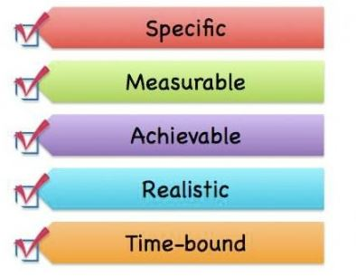
2017-18 Kansas Chapter SMART Goals

____________________________________________________________________________________ ______________________________________________________________________________________________________________________________________________________________________________________________________________________________________________________________________________________________________________________________________________________________________________________________________________________________________________________________________________________________________________________________________________________

